Record cover
A record cover is used to cover the records but also since there are usually printed a picture of some sort on it used in order to help sales.
During the era of vinyl records, 1950-1990, it was all about LP- and EP-records including singles that was stored in a papercover och plastic. The big format made the cover very important. The tradition of a illustrated covers began already during the era of old 78 records. The EP and singles usually came with a neutral cover containing only the recordcompanie logos and big holes so the recordlabel would be shown and read.
In the beginning of 1950s, when the LP-record became big, most of the covers was still illustrated. In the middle of the 50s it became more common with photobased record covers.
Your assignment will be to create your own record cover. Front and back. In order to create you cover you will use Photoshop. Before you start creating your album you will need to pick an artist or a band. You will also have to pick 10 songs, 5 of them to be on side A and 5 to be on side B. This information will be put on the back of your cover like on a ordirnary recordcover.
The general size of a LP-cover is 31.4 x 31.4 cm so besides that the rest is up to you as a designer!
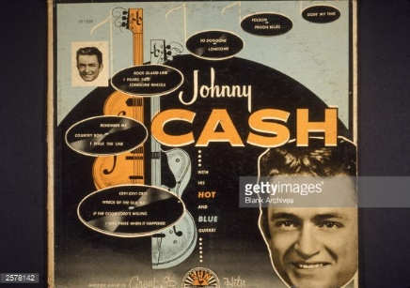
once you are finished you will present this to your class. Following points should be mentioned:

- What band did you pick?
- Show how other record covers with this band can look.
- Why did you design the cover the way you did?
- Talk about your design, how did you do it?
- Is there something more to tell?
